Notes on Feb 14, 2020 version of Chapter 3 – Science before Calculus

- On p. 17 – In the first paragraph, is it too succinct to say that Newton introduced the idea of “gravity”. Various ideas existed before Newton, though he is credited with putting this all together into a universal law of gravitation. We don’t want to go into a long discussion on this. Maybe the best way to say this is to say something like, “To be sure, Tartaglia wouldn’t have described his efforts this way, as it would take another hundred years for Newton to propose his law of universal gravitation.”
Done. 2/20/20, ecb

- On p. 17 – In the last paragraph it is primary tool, not primary too. Also, in that sentence, you want a comma after Renaissance.
Done. 2/20/20, ecb

- I really like that you put in a discussion about the difference between a variable and a constant (parameter). Recently, I’ve been in a habit of pointing this out in problems when I teach (especially since adopting our book). This is not often pointed out, and I think it leads to students saying things like “Can you put in numbers and not letters?” When they say that, I say ok, how about using the number $\frac{\sqrt{5}+7π}{4^{0.3}-678.986}$? Or why don’t we just call it $a$. I think this is a lesson for teachers too, as we are so comfortable using parameters that we forget where our students are. We should emphasize this in solving problems whenever we can.
Should this inserted discussion be pointed out a bit more? I don’t want to call it a “sidebar” as people might ignore the lesson in it. Could we call it something like Interjection: Variable Notation? I’m not sure if that would be the right word, but something to describe that we are taking a timeout from the problem to discuss something. Perhaps the right word IS Timeout: Variable Notation. What do you think? It might also be nice to use the same symbol (|X|X|X|X|X|X|) to start this discussion as you do to end it.
I have put this inside the “Notations” construct that I’ve used elsewhere. We may want to do more with it later. 2/21/20, ecb5

- I also like the idea of starting with light reflecting off of a mirror. This is much more natural than the original about rectangles. The rectangle one is good as a second example utilizing algebra and I like how you led into it.

- On p. 22: You might want to say End of Example 1 before the sentence “Consider the following variation on the problem, which can be done in a somewhat similar manner.”
Done. 2/22/20, ecb

- Also right after PIC #4, you say Problem 3. How about referring to it as PIC # 4.
This is part of a bigger problem. There are a great many reference that are either wrong, or undefined (so they show up as ??). This has been true since the beginning. I need to program a few TeX macros to fix this. When I do it’ll take care of most of these issues all at once. I put it off in the beginning cuz I wanted to write the book, not a bunch of macros. But it looks maybe the time has come for me to fix it. I’ll look into it. 2/21/20, ecb

- On p. 25, when you initially talk about the slope of a curve, you should probably say something like the slope of (a tangent line to) a curve. You can say that we will shorten this to the slope of a curve, but when we say this, we mean the slope of the tangent line to the curve at that point.
We should discuss this. I’ve gradually come around to talking about the “slope of a curve” rather than the “slope of the line tangent to the curve”. It seems to me that using differentials allows this. Since an infinitesimal can be thought of as an infinitely small straight line, it has a slope. Viewed this way the tangent line is just the (finite) extension of the differential. I’ve been explaining it to my students this way for a while and they don’t seem to have an issue with the idea that a curved line can have a slope that changes at each point.
I think the tangent line is an unnecessary distraction, at least in the beginning. Maybe we could talk about an “instantaneous slope?” Maybe not. Just an idea.

When we move on to the theory of limits, of course we’ll have to get more sophisticated.

In any case, I’m gonna hold off on changing this until we can discuss it. 2/22/20, ecb

- On p. 26, in PIC # 7, Should this be altered to a more general case? For example, it could be more like PIC # 8. How about this?

Problem in Context# 7:

- Use Fermat’s method for tangents to compute the slope of the tangent line to $y=x^{2}$ at the point $\left(x,x^{2}\right)$.
- Substitute the values $x=-2,-1,0,1,2$in your formula for the slope and graph this to see if this is consistent with the graph.
- What is the relationship between the slopes at $x$ and $-x$? Is this consistent with the graph?

End of PIC # 7
- You can add this into PIC # 8

- What can you say about the tangent lines at $(x,x^{3})$ and $(-x,-x^{3})$? Are your answers in part b consistent with this?
Done. Excellent idea! 2/22/20, ecb

- On p. 32 – At the end, saying that “Calculus is, at its heart, the mathematics of change” is somewhat repetitive with what you said earlier. I think you can omit this sentence.
Done. 2/22/20, ecb

- On p. 34 – You can specify that the telescope invented by Newton is a reflective telescope and is the design utilized in very large telescopes rather than the refractive design used by Galileo. It is also the shape of the reflective dish in a satellite dish. It might be nice to put a couple of pictures in.

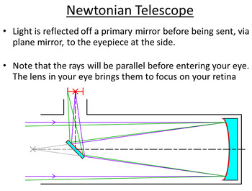https://ecdn.teacherspayteachers.com/thumbitem/Advanced-Level-Astrophysics-Reflecting-Telescope-Lesson-plan-and-PowerPoint--3048395-1500875497/original-3048395-1.jpg

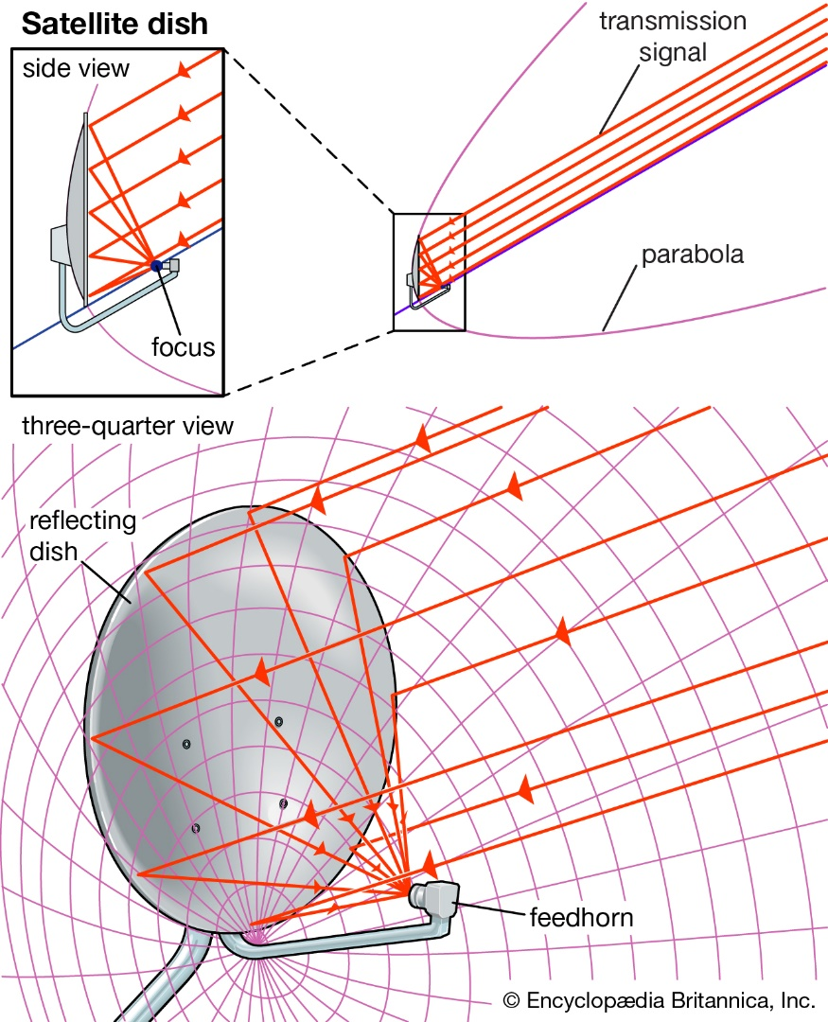

- https://cdn.britannica.com/82/72982-050-D21EE7F3/Satellite-dishes-satellite-dish-antenna-paraboloid-portions.jpg
I have inserted one of these images, and I have saved the other for possible inclusion later. The way images are included using LaTeX, makes it necessary to wait until we are nearly done with the book to make final decisions about their placement. 2/22/20, ecb

- On page 34, I would call the example Elliptic Curves (This would also necessitate changing the labeling of a parabolic and hyperbolic curve. How about labeling these Tangent to a parabola, Tangent to an ellipse and Tangent to a hyperbola?
Done. 2/22/20, ecb

- In Problem in Context # 17, you can change Problem in Context ?? to Problem in Context # 16.
Requires TeX macro programming. See above. 2/22/20, ecb

- Do we want an image of a Cassegrain telescope or no? Here is one, ‘I’ll leave it up to you as to whether we should use it. Actually, this is the design for a Cassegrain antenna. If you put this in, then it should probably come in after PIC # 18.

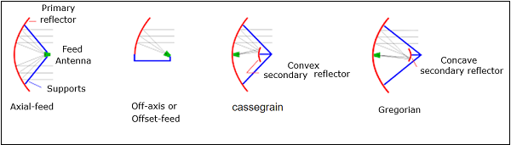

https://www.tutorialspoint.com/antenna_theory/images/gregorin_feed.jpg

Done. Actually, I created a new diagram with the same information as this one and used it. I had more flexibility that way. 2/22/20, ecb
- On page 36, do you want to put End of PIC # 19 before the comment about the futility of using Fermat’s method in Snell’s Law?
Done. 2/22/20, ecb

